**Part 1: Starting and Stopping the Routing and Remote Access service**

You will explore what happens when a service is stopped and then started. In this part, you will use routing and remote access service as the example service. This service allows the local device to become a router or a remote access server.

1. Navigate to the Control Panel > Click Network and Sharing Center.  
   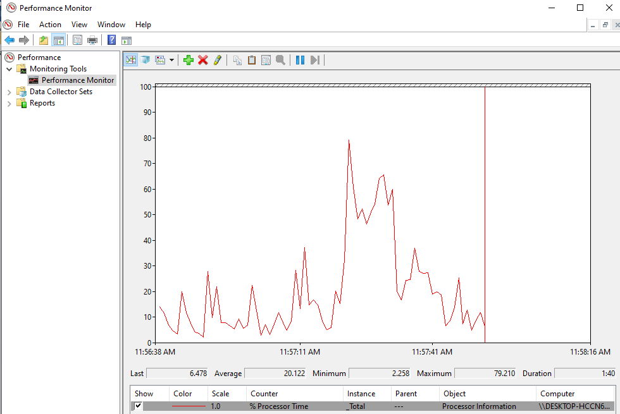

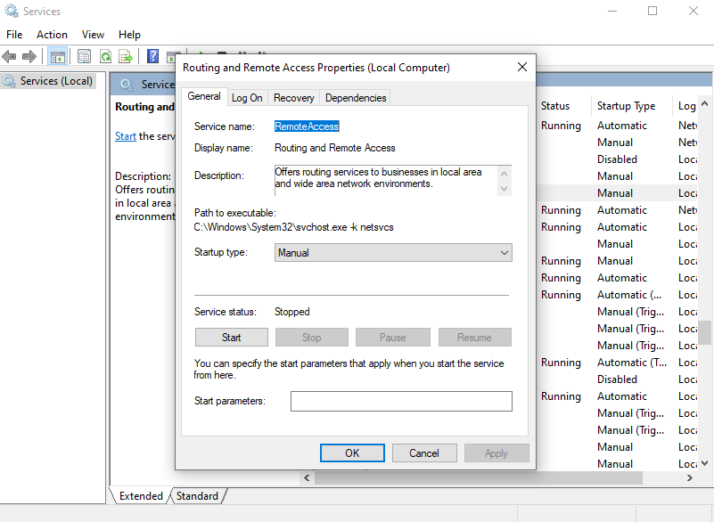

What changes appear in the right pane after stopping the Routing and Remote Access service?

The Incoming Connections icon is no longer displayed.

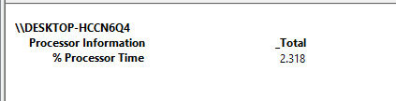

What values are displayed by the counter?

Processor Information % Processor Time: 2.318

What changes appear in the right pane after stopping the Routing and Remote Access service?  
The Incoming Connections icon is no longer displayed.

Which Counter is being recorded the most in the graph (hint: look at the graph color and Counter color)?  
%Processor Time

What is the Status and Startup Type for Routing and Remote Access?  
Status is blank and Startup Type is Disabled.

**Part 2: Working in the Computer Management Utility**

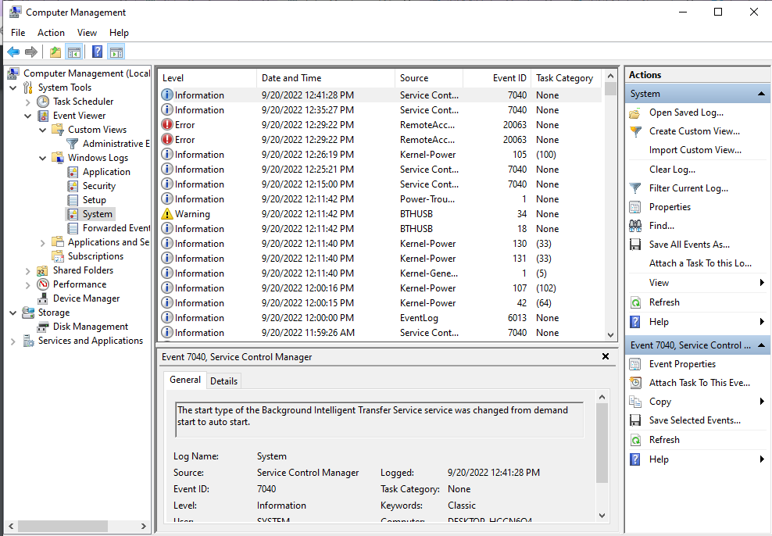

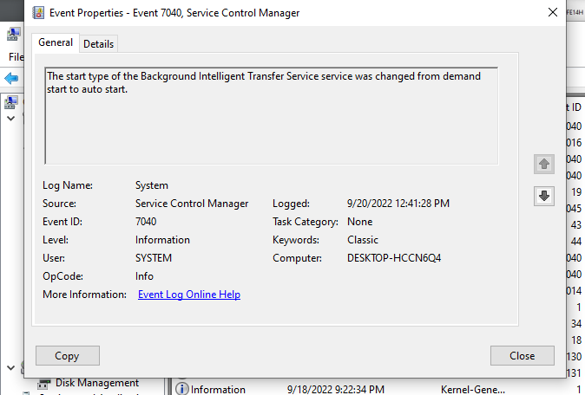

**Part 3: Configuring Administrative Tools**For the rest of this lab, you will configure Advanced Administrative Tool features and monitor how this affects the computer.

1. Click Control Panel > Administrative Tools > Performance Monitor. The Performance Monitor window opens. Expand Data Collector Sets. Right-click User Defined, and select New > Data Collector Set.

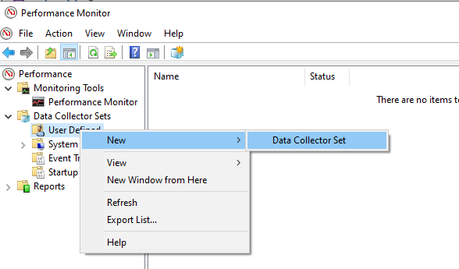

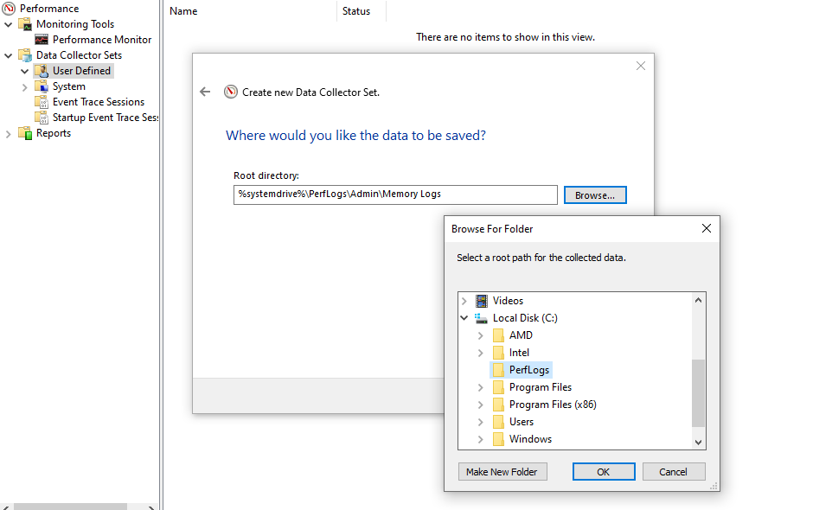

What is the full path name to the example file?  
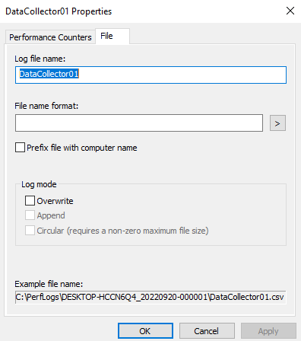

What change do you notice for the Memory Logs icon?

The green arrow has been removed from the icon.

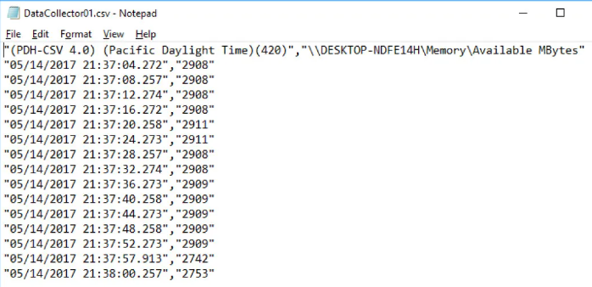  
  
What does the column farthest to the right show?

Available memory in MBytes.